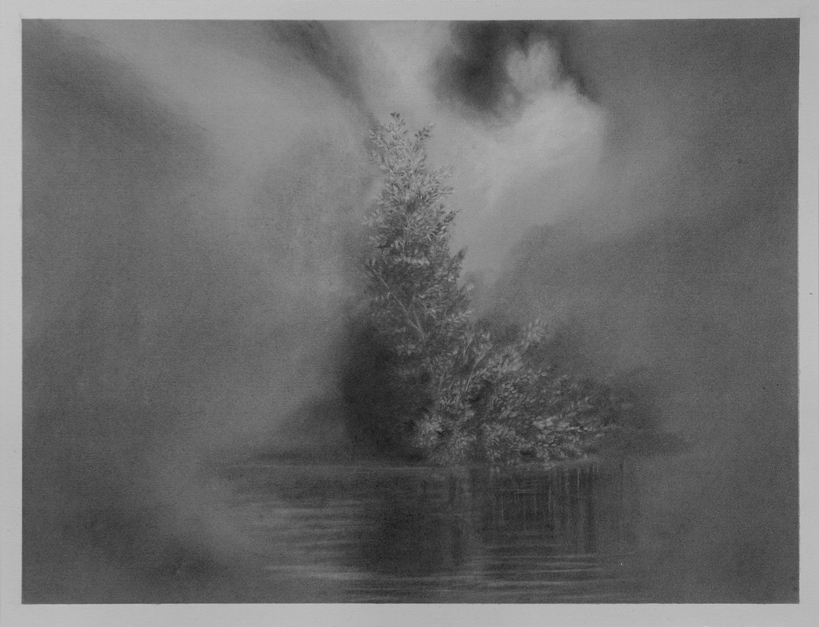

Untitled  
Graphite and charcoal on paper  
10.8 in x 14.5in   
2024

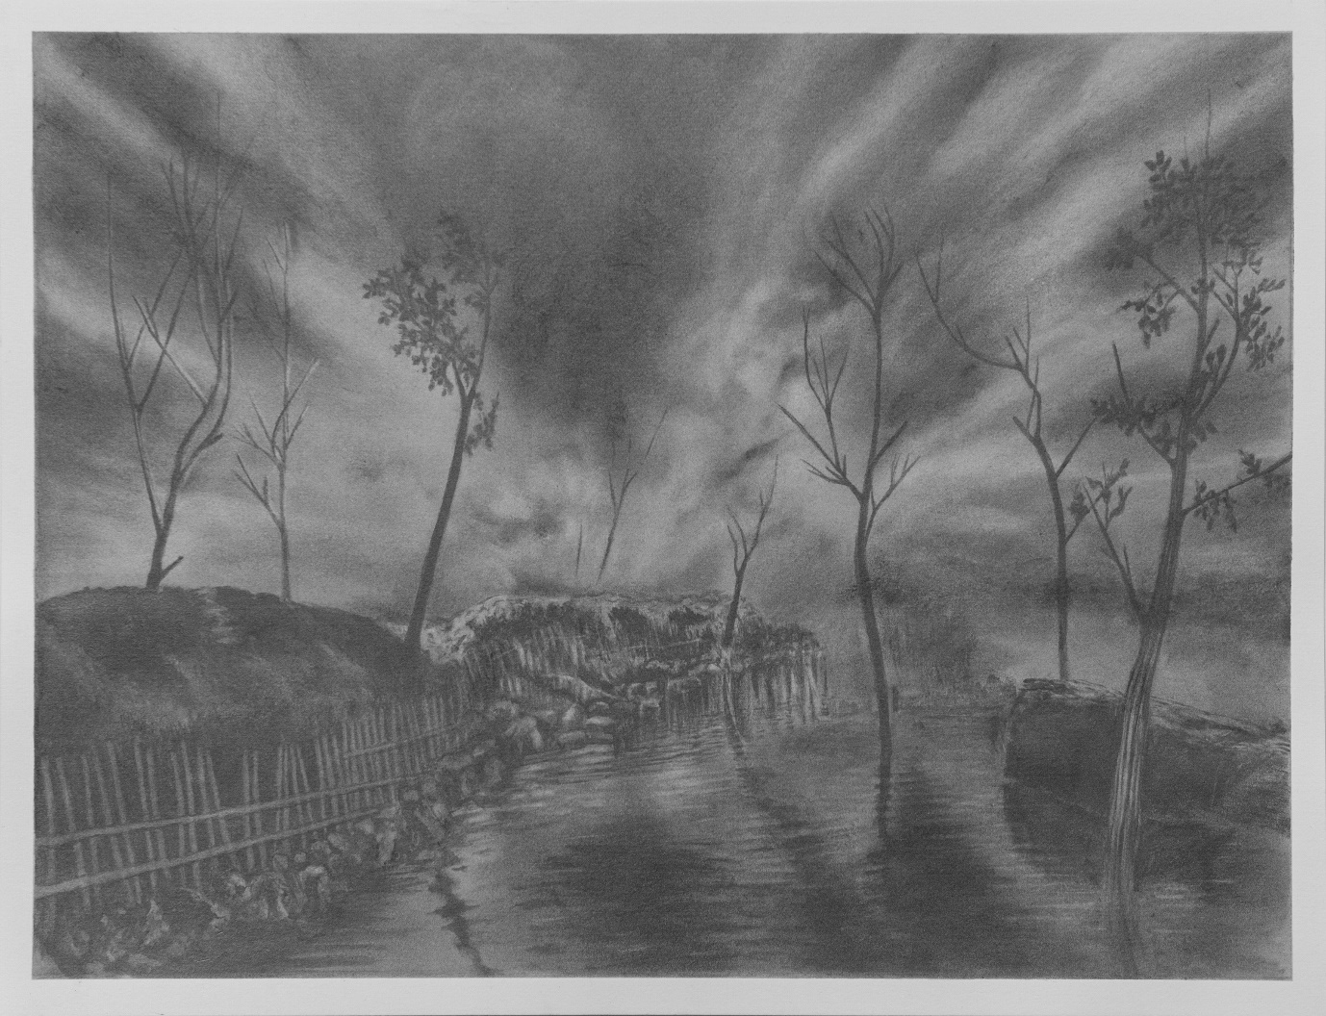

Untitled  
Graphite and charcoal on paper  
10.8 in x 14.5in   
2024

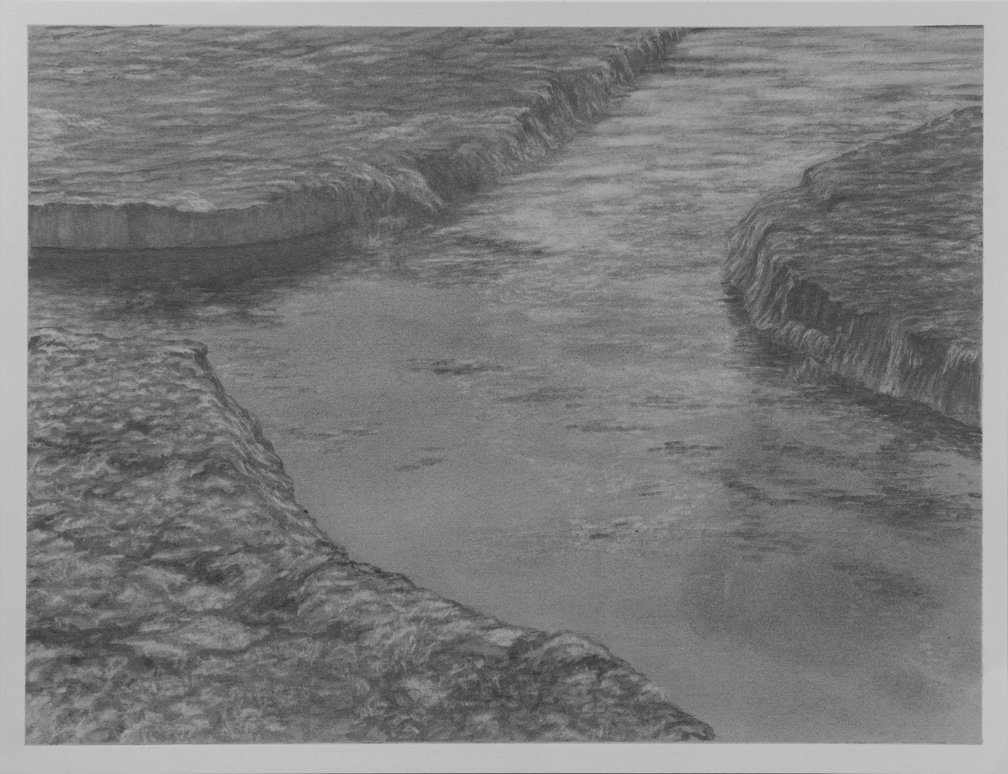

Untitled  
Graphite and charcoal on paper  
10.8 in x 14.5in   
2024

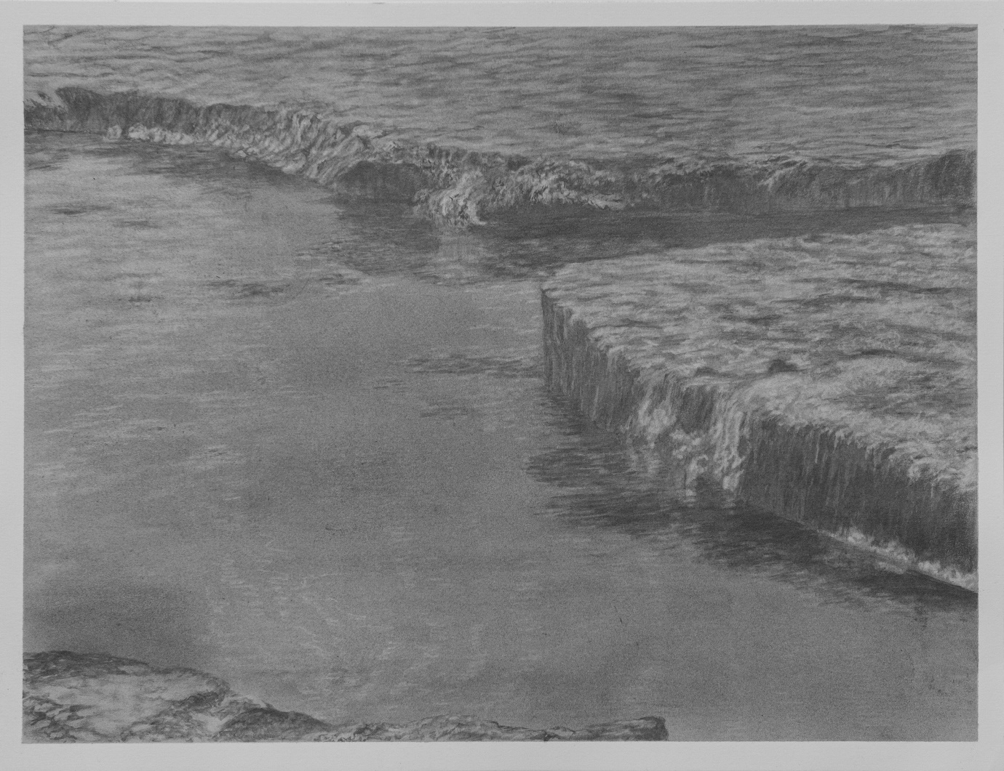

Untitled  
Graphite and charcoal on paper  
10.8 in x 14.5in   
2024

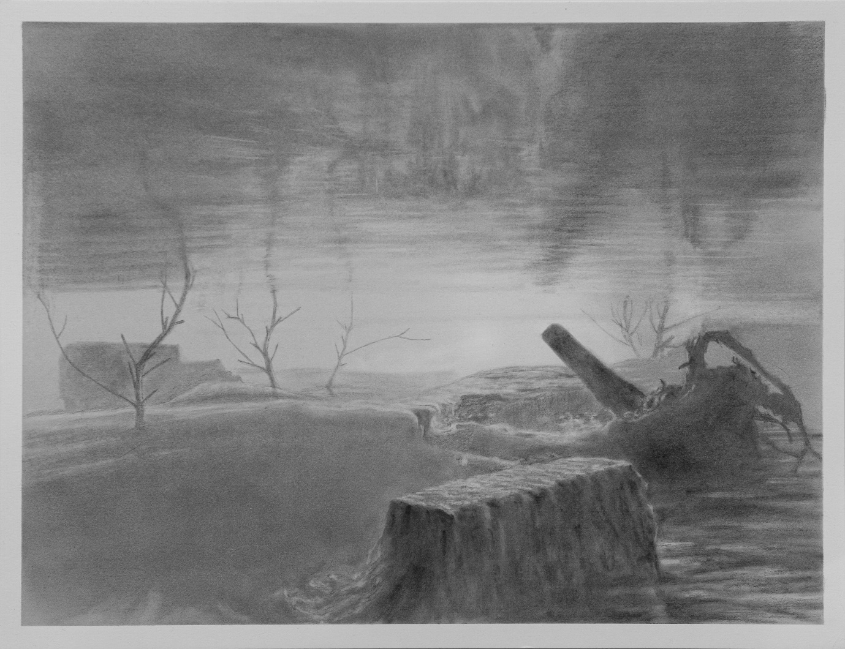

Untitled  
Graphite and charcoal on paper  
10.8 in x 14.5in   
2024

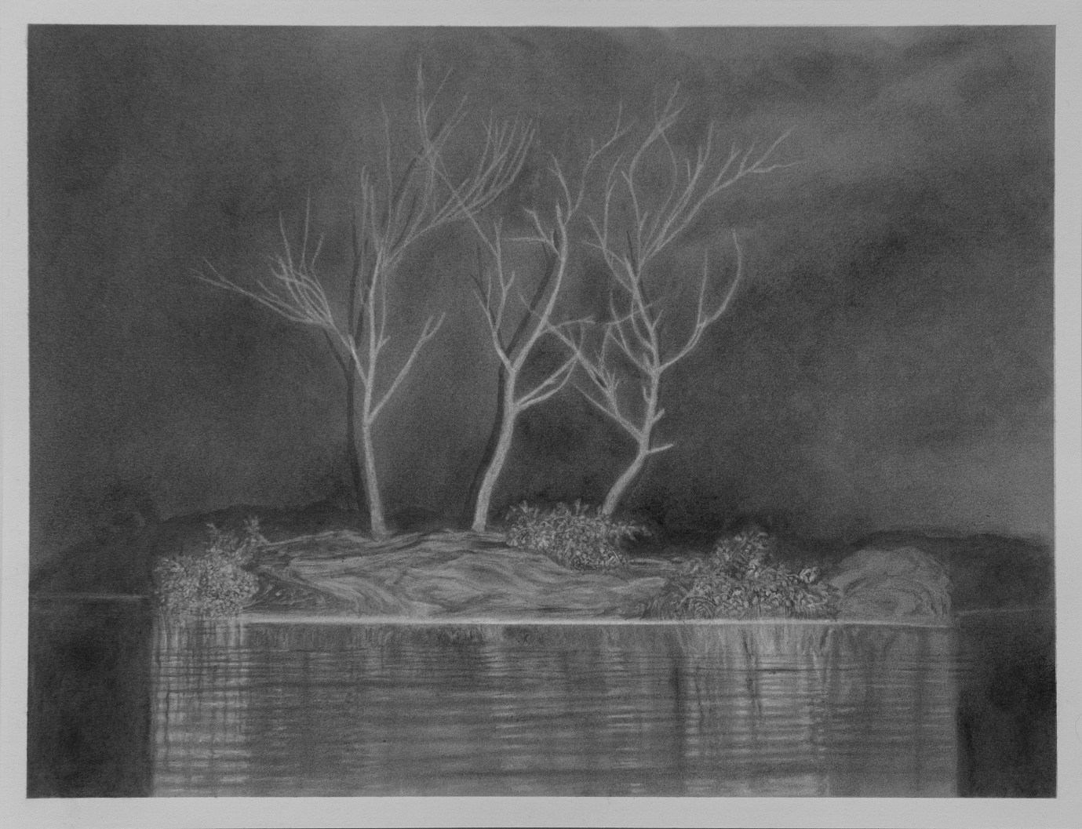

Untitled  
Graphite and charcoal on paper  
10.8 in x 14.5in   
2024

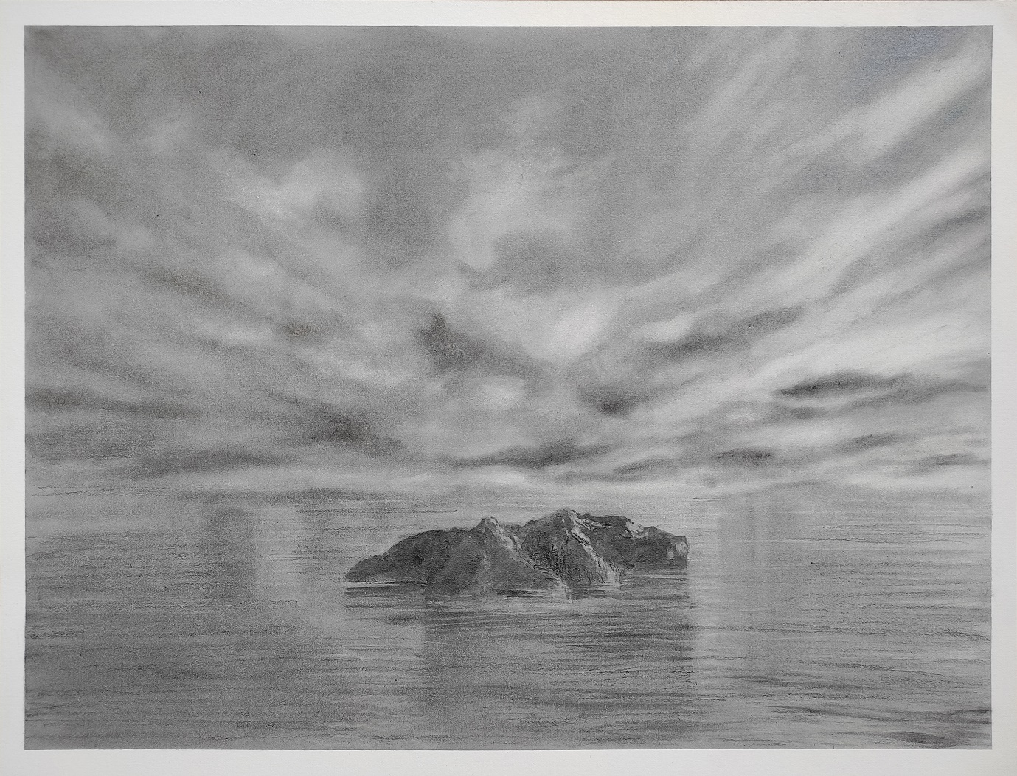

Untitled  
Graphite and charcoal on paper  
10.8 in x 14.5in   
2024

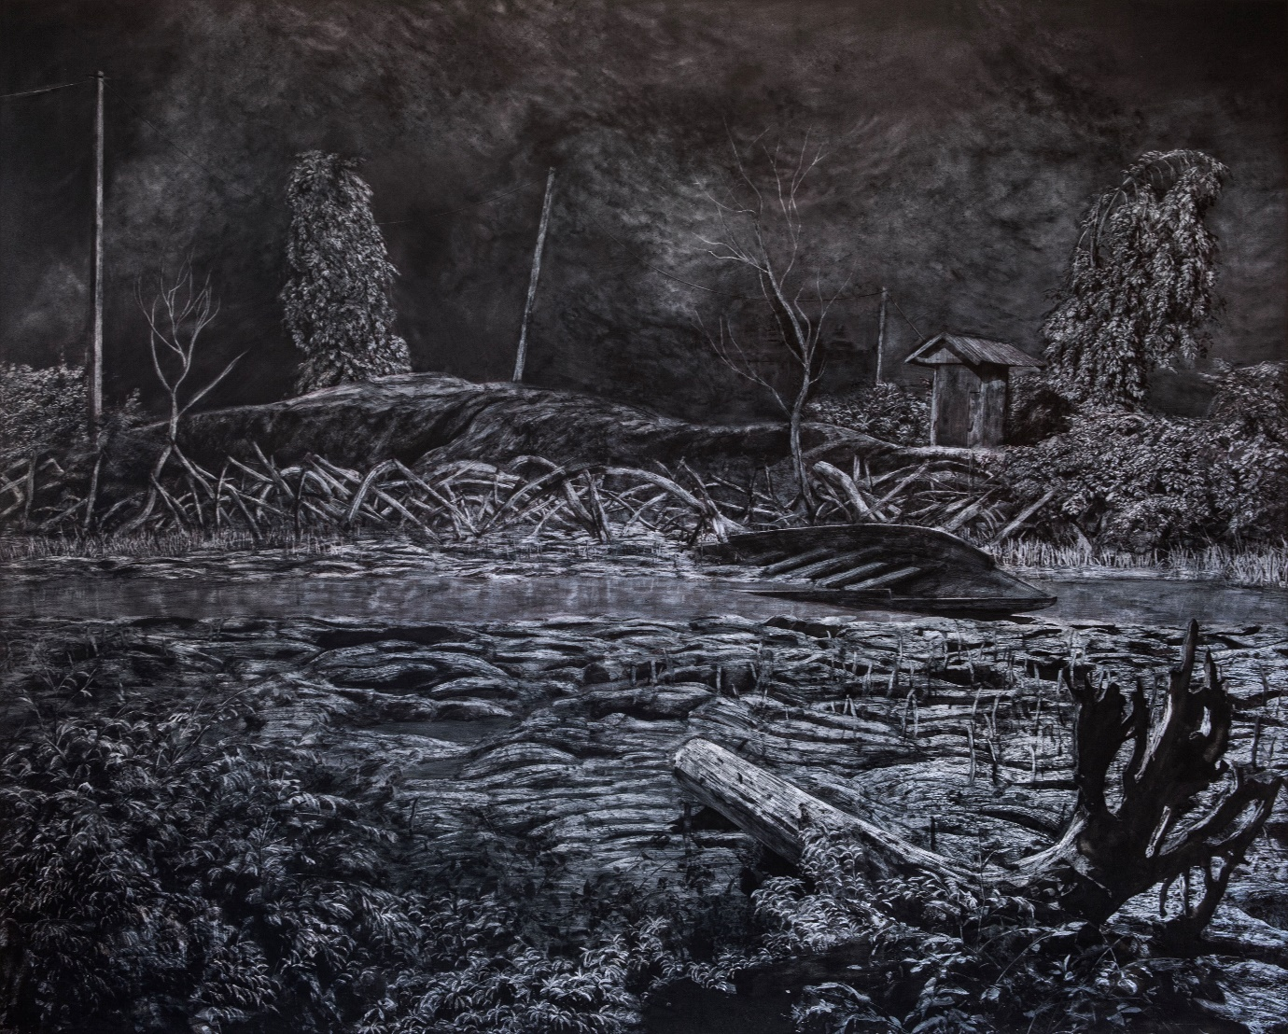

Untitled  
Graphite and charcoal on paper  
41.7 in x 52 in   
2023

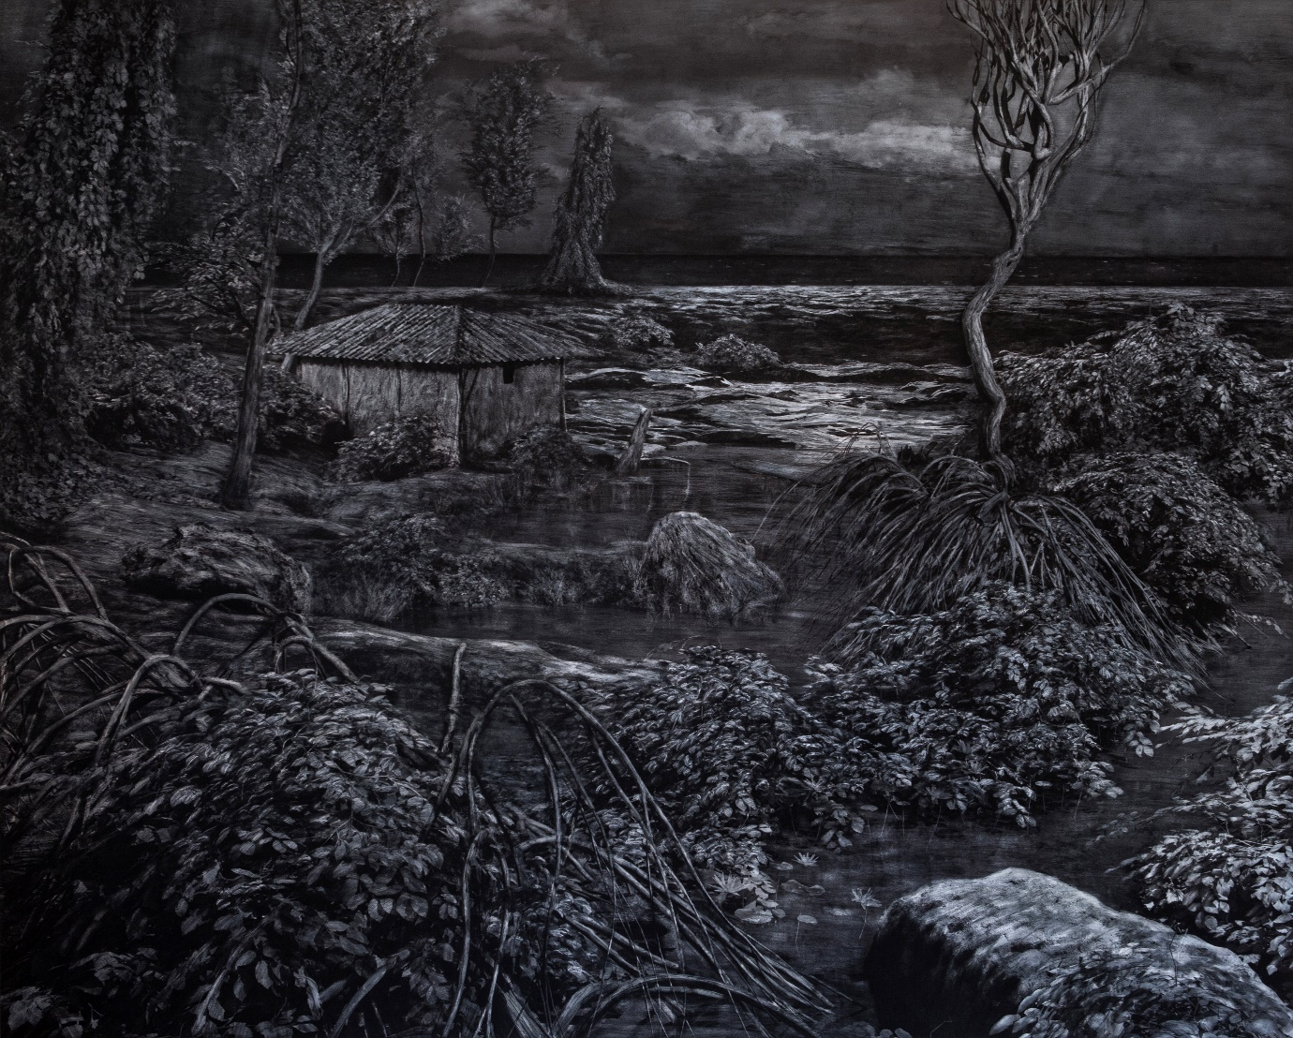

Untitled  
Graphite and charcoal on paper  
41.7 in x 52 in   
2023

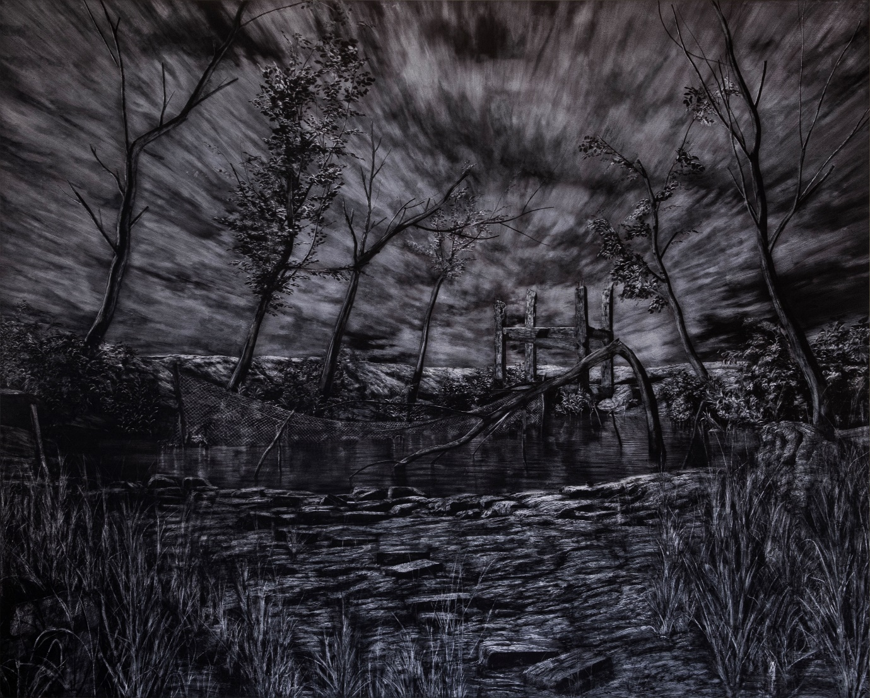

Untitled  
Graphite and charcoal on paper  
41.7 in x 52 in   
2023

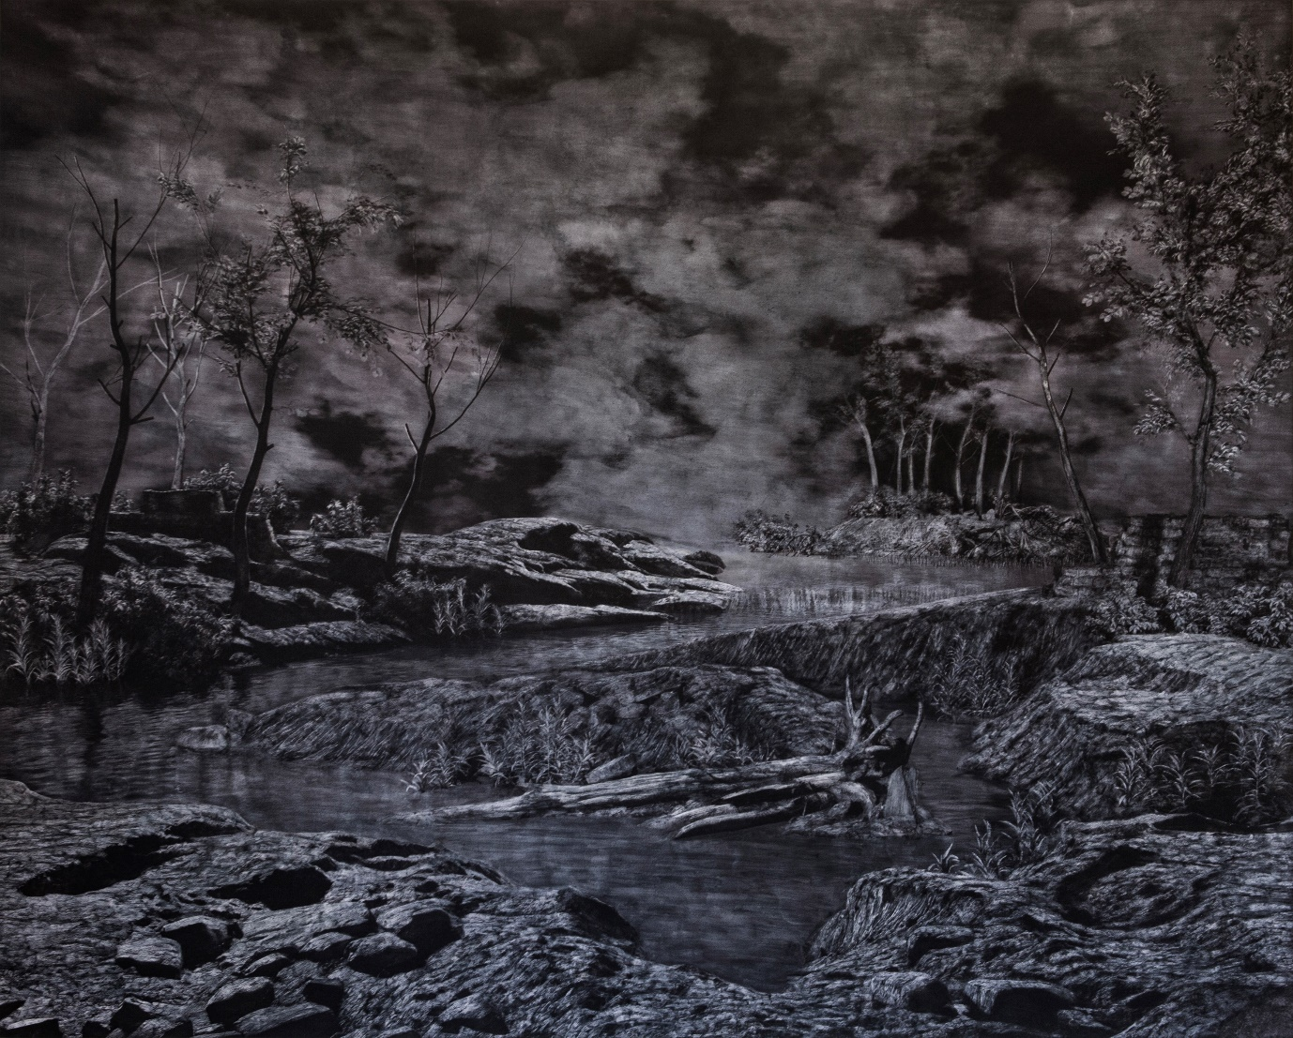

Untitled  
Graphite and charcoal on paper  
41.7 in x 52 in   
2023

Caption for all installation Shots:

*Archipelago of Storms and Spirits,* Jhaveri Contemporary, Mumbai, 2024